AI Camera 2.0 Basic Projects

Lesson 8: Line-Following Car
Ages: 12 and up
Duration: 45 minutes

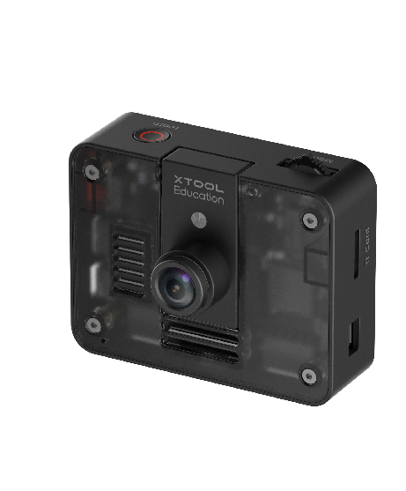

Objectives:
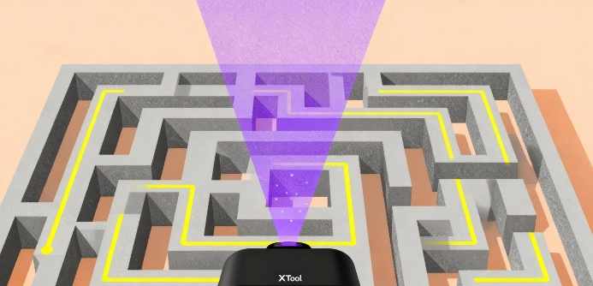
By the end of class, students will be able to:
- Understand the basic principles of route recognition and image processing
- Master the method of using the AI Camera to obtain path deviation values and control the car for line following
- Develop logical thinking and problem-solving skills through debugging and program optimization

Overview
This course utilizes the route recognition function of the AI Camera 2.0 to guide students in implementing an automatic line-following car project. Students will learn how to obtain path deviation values and use a proportional control algorithm to dynamically adjust the car's speed, ultimately completing an intelligent car system that can stably drive along a black line. The course emphasizes the transition from theory to practice, cultivating students' computational thinking and robotics programming skills.

Pre-lesson Checklist
For the teacher:
- Computer with mBlock installed and tested;
- Adequate number of mBot2 robots (fully charged);
- AI Cameras compatible with mBot2;
- CyberPi and connection cables;
- Printed line-following field (black and white route map);
For the students:
- Computer with mBlock installed and ready;
- mBot2 robot and AI camera set per group;
- CyberPi and connection cable;
- Line-following field (can be made using black and white tape);
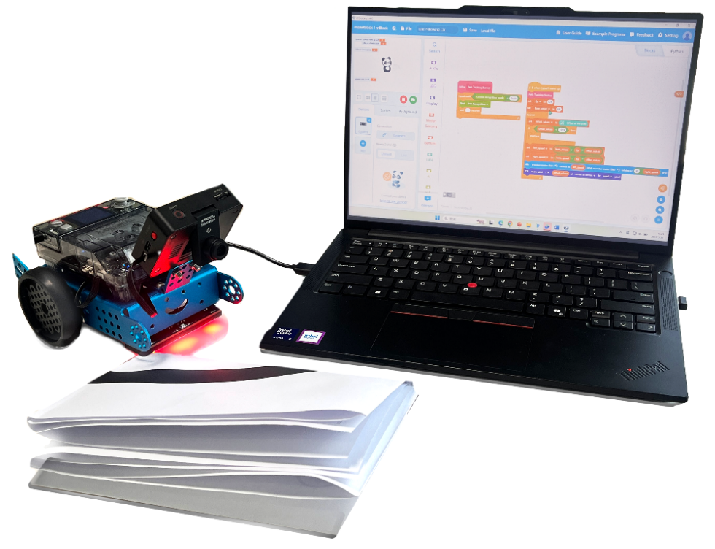

Agenda (45minutes)
Duration | Content
5 minutes | Section 1 - Introduction  - Demonstrate the line-following car automatically driving along a black line;  - Interactive question: "How does the car 'see' the route?"
10 minutes | Section 2 - Explore  - Explain how the AI Camera recognizes routes and outputs deviation values;
15 minutes | Section 3 - Create and practice  - Set up the programming environment and create necessary variables;  - Design the line-following control program and debug parameters;
10 minutes | Section 4 - Presentation  - Invite 2-3 groups of students to demonstrate their line-following results;  - Share discoveries and solutions during the debugging process;
5 minutes | Section 5 - Evaluate  - Review the problems they met and how they solved;  - Discuss applications of path tracking technology in other scenarios;

Activities

Section 1 - Introduction
In this lesson, we will explore how to use the AI Camera's visual recognition technology to enable robots to perceive paths and autonomously follow lines. By capturing ground images and identifying tracks through the AI Camera, the robot can analyze its driving status in real-time and make corresponding motion decisions.

Section 2 - Explore
The line-following functionality relies on the AI Camera's visual recognition and data processing capabilities to analyze ground paths. The system captures real-time terrain images and identifies black trajectory lines, laying the foundation for autonomous navigation and motion control.
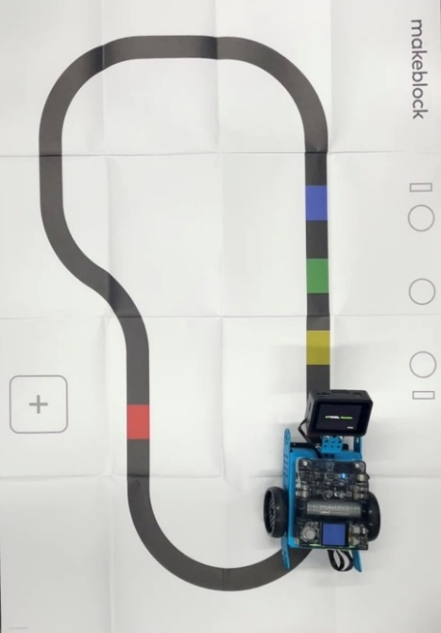
The AI Camera extracts features of the trajectory line through image processing algorithms and calculates the vehicle's deviation relative to the path. A deviation value of zero indicates the car is centered on the path; a negative value indicates a left deviation, while a positive value indicates a right deviation. This value serves as a critical reference for determining the driving status and executing corrective actions.
Based on real-time deviation values, the control system dynamically adjusts the speeds of the left and right wheels to achieve directional correction. This closed-loop feedback mechanism enables the vehicle to accurately and stably follow the predetermined route, demonstrating the effective integration of visual perception and motion execution.

Section 3 – Create and practice
In this section, students will work in groups to build a complete line-following car project through hands-on practice.
Task 1: Initialize programming environment and variable setup
Step 1: Set up programming environment.In the mBlock programming environment, click the [Extensions] button in the lower left corner and add the [AI Camera 2.0] and [mBot2 Shield] modules. | 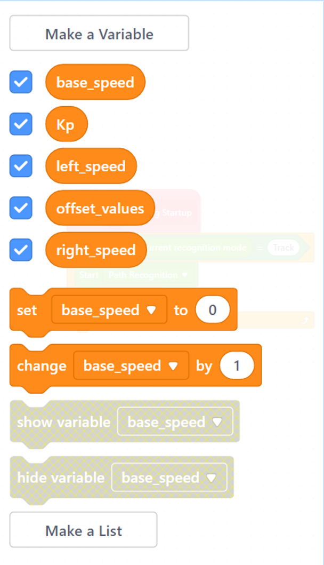
Step 2: Define control variables.
Base_speed: The baseline motor speed set for the mBot2 car based on actual conditions.
Left_speed: The speed of the mBot2 car's left wheel.
Right_speed: The speed of the mBot2 car's right wheel.
Offset_values: The path deviation value recognized by the AI Camera.
Task 2: Line-following program design and implementation
Step 3: Write main line-following loop. Use a loop structure to continuously obtain route recognition data from the AI Camera and update the deviation value. Calculate the left and right motor speeds based on the deviation value, and use conditional statements to achieve directional correction. | 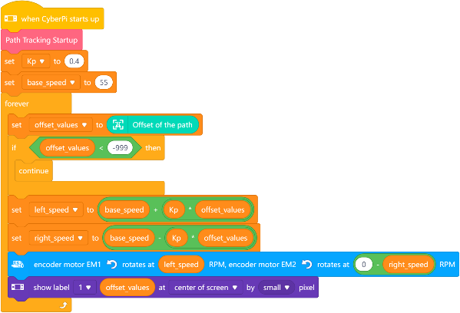
Step 4: System debugging and parameter optimization. Through experimental testing, optimize the baseline speed and adjustment parameters to make the line-following motion smoother and more reliable.

Section 4 - Presentation
In this session, students are invited to demonstrate their completed line-following robots and compare project outcomes across groups. During demonstrations, each group should: Which group's line-following car achieved the highest level of completion? What challenges did you encounter during the process?
After 2-3 groups have presented, the teacher will facilitate a class discussion focusing on: What discoveries and solutions did each group develop during the parameter debugging process, and what are the advantages and limitations of visual recognition technology compared to traditional sensor-based solutions?

Section 5 - Evaluate
Now let's review some key points in this lesson.
- What was the biggest challenge your team faced in today's project, and how did you collaborate to resolve it?
- In what other scenarios could the path tracking be applied?

